Quantum interference lab report

Xiaoyang Yu

**Abstract**

In this experiment we explore the wave-particle duality of photon. First we conduct two single slits diffraction experiments and a double slits interference experiment, this illustrate the wave behavior of photons. Then we do double slits experiment again but allow only one photon to pass the slits each time. We still observed the interference pattern, this means a single photon can “interfere” with itself. We proved that this wave-particle duality is the fundamental property of photon.

**Introduction**

In quantum theory, all particles have “wave-particle duality” property. That is, a particle possesses both wave and particle properties at the same time, all the time. This concept might be difficult to understand when encountered first time, since we tend to think that wave and particle are mutually exclusive property. But this is not true. Although in certain situations, maybe one property dominates the behavior of a particle or numbers of particles, but if we observe more closely, we will find the other property display itself. The two property must both exist at the same can we explain some of the behavior of particles, which will be shown in this experiment. This experiment attempts to illustrate the concept of “wave-particle duality” by observing single slit diffraction and double slits interference of photons.

**Theory**

In ideal single slit diffraction and double slits interference situation, a monochromatic light travel from infinitely far away to a single slit or double slits, then the diffracted or interfered light travels infinitely far to a screen, at where it displays its pattern and observed by us. The slits used have the same width and infinite length. In this idea situation we have the following equations.

According to the *HyperPhysics* website, the single slit interference pattern satisfies this equation:

$I=I_{0}\frac{{(\sin{\frac{δ}{2}})}^{2}}{({\frac{δ}{2})}^{2}}$ (1)

Where $δ=\frac{2πa\sin{θ}}{λ}$. θ is the angular deviation of the center point, in other words, θ is the angle between the observing point to the center of slits, and the center of maximum to the center of slits. At the center of maximum, θ=0. I can be intensity or any other parameters that is proportional to intensity, I0 is the maximum quantity of the parameters, measured at the center of the screen.

According to the lab manual from the University of Iowa, the double slits interference pattern satisfies this equation:

$I=I_{0}{\left(\cos{β}\right)}^{2}{(\frac{\sin{α}}{α})}^{2}$ (2)

Where $α=\frac{πa}{λ}\sin{θ}$, $β=\frac{πd}{λ}\sin{θ}$.

If we reduce the light intensity to a degree that only one photon travels through the slits until it reaches the screen, so that there are no other photons to be interfered with, we will still observe the interference pattern, with *I* be the number of photons detected at the corresponding position range.

**Experiment procedure**

We use the TeachSpin two-slit interference apparatus, as shown in figure 1. The diffraction and interference process happen inside the black tube, in left end is the light source, in the right end is the detector.

Figure 1: Apparatus shown with lid in place. From the University of Iowa lab manual.

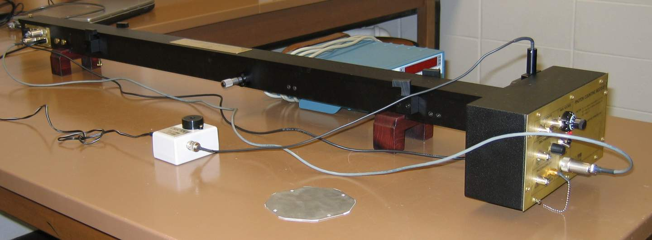

First we use the laser emitter as light source, the intensity of the light will be high, hence we expect normal diffraction and interference pattern. The detector we use for laser is a photon diode, then we use a voltage meter to measure the intensity. We measure the voltage at different positions indicated by a micrometer on the apparatus. We will do two single slit diffraction measurements, one for the left slit and one for the right slit; and one double slits interference measurement. Then we plot the measured result and compare with the theoretical prediction from eq (1) and (2). Here I in the equation will be the voltage measured.

Then we switch the light source to a light bulb and switch the detector to a photomultiplier tube (PMT). Adjust the intensity of the light bulb so that at the center maximum position the PMT reads about 1000 counts per second. This will ensure that on average there is only one photon traveling in the apparatus. Then we measure and plot the counts at different position, then compare with the theoretical prediction. I in the equation will be the counts measured.

**Result and analysis**

After all the experiment procedures were done, we have 4 sets of data, plot in figure 2-7.

For figure 2, the experiment data seems to fit well with the theoretical predicted value. Figure 3 shows some disagreement with the experiment data and the expected value. It might because of misalignment of the laser emitter and the slits. Here are 3 possible reasons that causes this misalignment:

1. Because of small shake accidently made by me while operating the equipment, the alignment was interrupted.
2. Because of heat up of the light source during the previous experiment procedure, the temperature rising might cause some unpredictable result.
3. Another possible reason for the disagreement is due to the slit blocker was not completely moved out of place so that it blocked a fraction of the diffracted light. Considering that the double slits interference pattern agrees well with the experiment result, indicating the misalignment didn’t propagate through to next part of experiment. Also notice that figure 3 has smaller maximum intensity compared with figure 2, knowing that I didn’t change the laser intensity during the experiment.

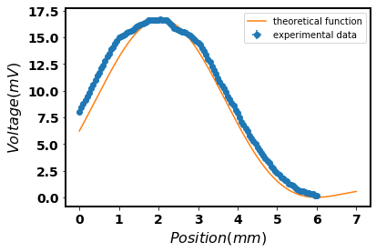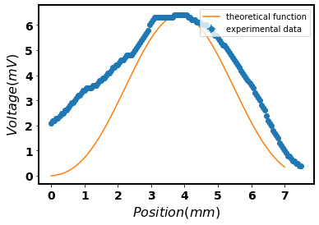

Figure 3: Laser right slit diffraction pattern.

Figure 2: Laser left slit diffraction pattern, detected by photon diode.

Figure 4 is the laser emitter double slits interference pattern. In figure 5, I extracted the local extremes form figure 4, except the overall maxima, since the experimental and theoretical maxima are the same anyway. First we compare the vertical positions of the local extremes. From the graphs it’s apparent that theory predicted local maxima values differ with the experiment data. The further local maxima away from the central maxima position, the difference is bigger. This could because our experiment set up is not completely ideal, it’s only an approximation to ideal situation. Then we compare the horizontal positions of the local extremes, it’s not very clear to see the difference in the graph, quantitative compare is in table 1. We see that all the theoretical predictions fall within 1δ of experiment data.

Exactly similar interference pattern can be observed from the light bulb interference experiment. The results are shown in figure 6-7 and table 2. We see that the experiment data agree well with the interference theory prediction, indicating that interference happened even only one photon is allowed to pass through the slits. This means the wave property of photon is supported by this experiment.

The particle property of photon can be supported by the oscilloscope reading of PMT. The oscilloscope shows discrete signal spikes, indicating that photons were detected quantumly. This is an evidence of particle property of photon.

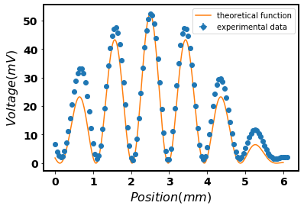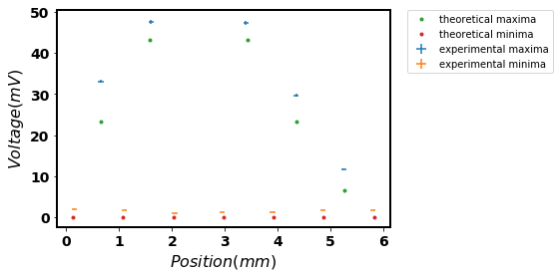

Figure 5: local extremes extracted from laser interference pattern. Length of lines of experiment data represent its error.

Table 1: quantitative compare of laser double slits interference extreme points, horizontally. The experimental extreme points have δ=0.05mm.

Figure 4: Laser double slits interference pattern.

|  |  |  |  |  |  |  |  |
| --- | --- | --- | --- | --- | --- | --- | --- |
| Theoretical local maxima (mm) | 0.644 | 1.57 | 3.43 | 4.356 | 5.263 |  |  |
| Experimental local maxima (mm) | 0.65 | 1.6 | 3.4 | 4.35 | 5.25 |  |  |
| difference | 1δ | 1δ | 1δ | 1δ | 1δ |  |  |
| Theoretical local minima (mm) | 0.127 | 1.076 | 2.025 | 2.975 | 3.924 | 4.873 | 5.822 |
| Experimental local minima (mm) | 0.15 | 1.1 | 2.05 | 2.95 | 3.9 | 4.85 | 5.8 |
| difference | 1δ | 1δ | 1δ | 1δ | 1δ | 1δ | 1δ |

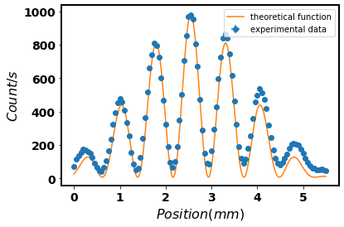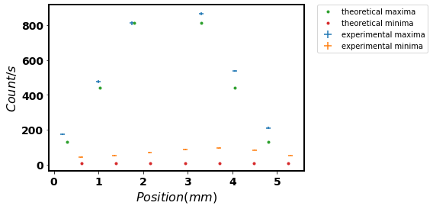

Figure 7: Local extreme extracted from light bulb interference pattern. Length of lines of experiment data represent its error.

Figure 6: Light bulb double slits interference pattern, one photon through the slits each time. Detected by PMT.

Table 2: quantitative compare of light bulb double slits interference extreme points, horizontally. The experimental extreme points have δ=0.05mm.

|  |  |  |  |  |  |  |  |
| --- | --- | --- | --- | --- | --- | --- | --- |
| Theoretical local maxima (mm) | 0.298 | 1.038 | 1.792 | 3.308 | 4.062 | 4.802 |  |
| Experimental local maxima (mm) | 0.2 | 1.0 | 1.75 | 3.3 | 4.05 | 4.8 |  |
| difference | 2δ | 1δ | 1δ | 1δ | 1δ | 1δ |  |
| Theoretical local minima (mm) | 0.617 | 1.39 | 2.163 | 2.937 | 3.71 | 4.483 | 5.257 |
| Experimental local minima (mm) | 0.6 | 1.35 | 2.15 | 2.95 | 3.7 | 4.5 | 5.3 |
| difference | 1δ | 1δ | 1δ | 1δ | 1δ | 1δ | 1δ |

**Conclusion**

The left slit diffraction result is qualitatively consistent with theoretical prediction. The right single slit diffraction seems inconsistent with the theoretical prediction, but it’s mostly likely due to my incorrect operation of experiment equipment. It’s very likely I can get a consistent result if I do the procedure correct, since the left slit experiment works well. Considering the light bulb interference result, almost all the experiment result differs with the theoretical prediction by within 1δ. Overall our experiment results agree well with theoretical prediction. We can say that this experiment is a strong support of wave-particle dual property of photon.

**Reference**

Harrington T. Taber, Anthony Moller. Expriment Q10: Quantum Interference*. Intermediate Laboratory Manual.* The University of Iowa. 2013.

**Appendix**

Xlsx and csv files: row data.

Q10DataProcessing.py: code to process all the data.